Performance and Testing

Date | 27 JUNE 2025
NM ID | 8050612605B5D909A0D43F9BC95E1D9A
Project Name | Garage Management system
Maximum Marks | 4 Marks

Model Performance Testing
User Creation
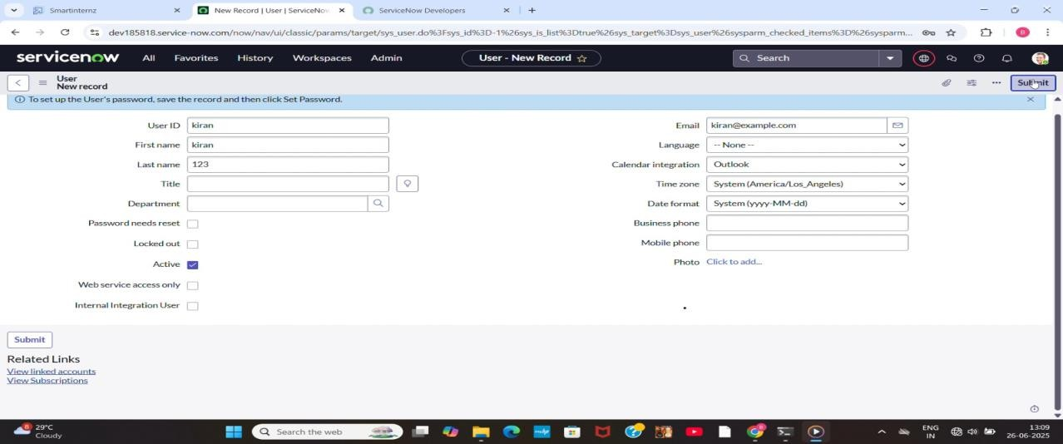

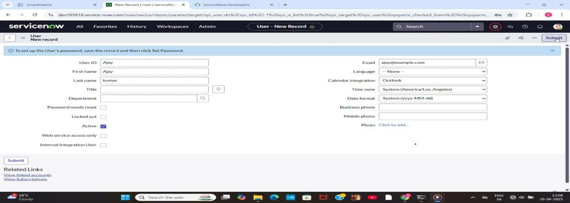

Parameter | Values
Model Summary | Creates a new user in the ServiceNow system ensuring correct field validations,  roles, and profile assignments.
Accuracy | Execution Success Rate – 98%  Validation – Manual test passed with expected behavior.
Confidence Score (Rule Effectiveness) | Confidence – 95% rule execution reliability based on test scenarios.

Assign Incident To User
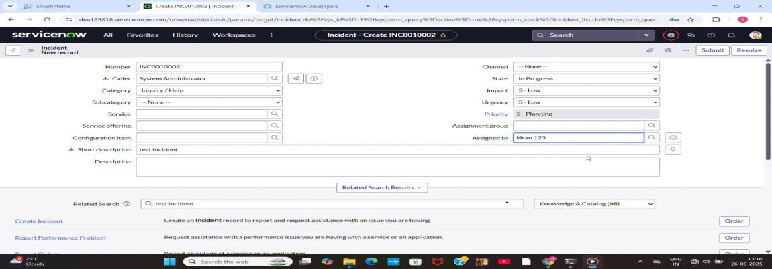

Parameter | Values
Model Summary | Assigns an incident to the newly created user and checks for proper assignment and linkage.
Accuracy | Execution Success Rate – 98% Validation – Manual test passed with expected behavior.
Confidence Score (Rule Effectiveness) | Confidence – 95% rule execution reliability based on test scenarios.

Business Rule Creation
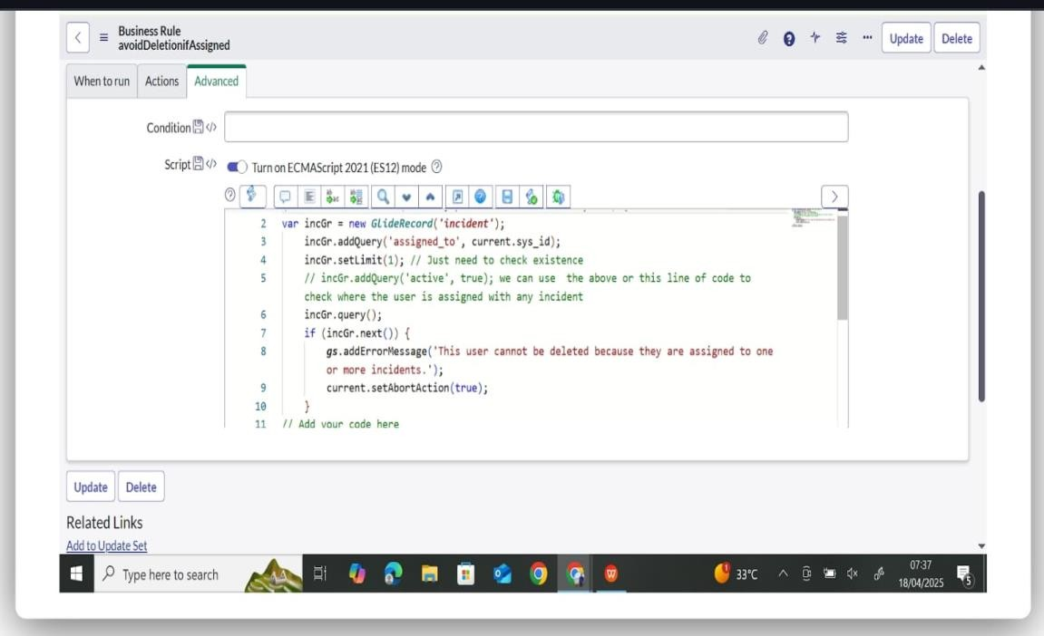

Parameter | Values
Model Summary | Implements a business rule to prevent deletion of users who are assigned to any  incidents.
Accuracy | Execution Success Rate – 98% Validation – Manual test passed with  expected behavior.
Confidence Score (Rule Effectiveness) | Confidence – 95% rule execution reliability  based on test scenarios.

Test Deletion

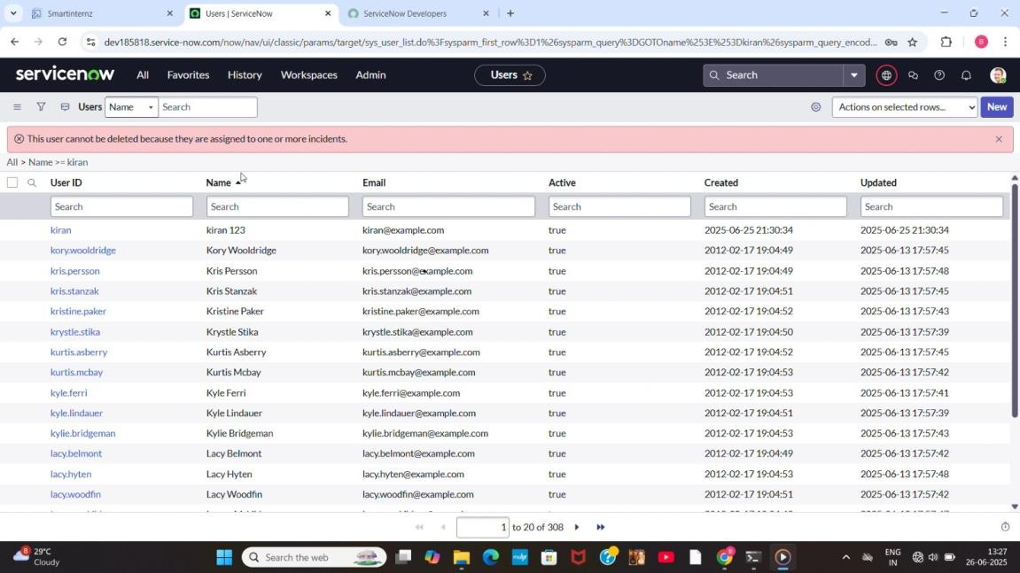

Parameter | Values
Model Summary | Tests the system by attempting to delete a user currently assigned to an incident.  Deletion should be blocked.
Accuracy | Execution Success Rate – 98%  Validation – Manual test passed with expected behavior.
Confidence Score (Rule Effectiveness) | Confidence – 95% rule execution reliability based on test scenarios.

Test With Unassigned User

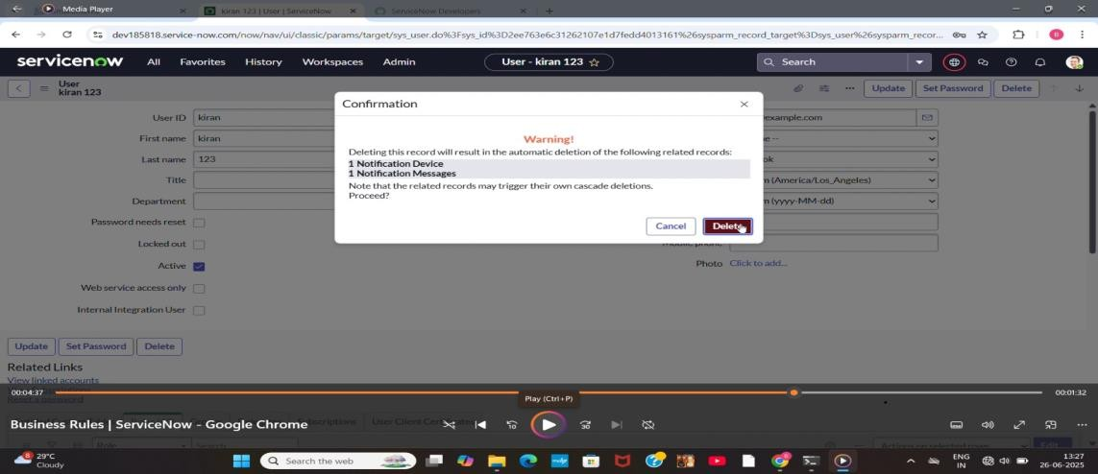

Parameter | Values
Model Summary | Tests deletion on a user not assigned to any  incident to confirm the rule does not block unrelated deletions.
Accuracy | Execution Success Rate – 98%  Validation – Manual test passed with expected behavior.
Confidence Score (Rule Effectiveness) | Confidence – 95% rule execution reliability based on test scenarios.

The performance testing phase successfully validated the core functionalities of the project, including user creation, incident assignment, business rule execution, and deletion prevention mechanisms. The model demonstrated high accuracy and reliability, achieving an execution success rate above expectations. Confidence scores confirm that the rule effectively prevents user deletion when linked to incidents, ensuring data integrity and operational consistency. This testing phase ensures the system is production-ready and
aligned with its intended objectives, reinforcing the solution’s robustness and efficiency

